What is an occupational health and safety (OH&S) program?
A health and safety program is a definite plan of action designed to prevent accidents and occupational diseases. Because organizations differ, a program developed for one organization cannot necessarily be expected to meet the needs of another.
Workers should be protected from occupational risks they could be exposed to. This could be achieved through a risk management process, which involves risk analysis, risk assessment and risk control practices.

Prevention of occupational risks
Within the context of their general obligations, employers have to take the necessary measures for the safety and health protection of workers, including prevention of occupational risks. This is a quite basic principle in the law of many countries.
For preventing occupational accidents and ill health, employers must perform risk assessment regarding safety and health at work, and decide on protective measures to take and, if necessary, on protective equipment to use. It is advisable that risk assessment should be done at least every year or every time a change is introduced in the workplace, for instance due to the introduction of new work equipment or procedure, or the use of a new chemical substance or preparation.

Important concepts
Important concepts in risk management are the concepts of hazard and risk. A hazard is a source, situation, or act with a potential for harm in terms of human injury or ill health, or a combination of theseTherefore, a hazard can be anything present in the workplace that has the potential to cause an injury to workers, either a work accident or an occupational disease. Examples of physical hazardous situations can be working on a ladder, handling chemicals substances or walking on a wet floor. Examples of psychosocial hazardous situations are job content, job insecurity, isolation, bullying or harassment, since employees’ health are affected by their perceptions and experience about work organization and other related factors.
Risk is the combination of the likelihood of an occurrence of a hazardous event or exposure and the severity of injury or ill health that can be caused by the event or exposure

What are examples of responsibilities of workers?
Examples of responsibilities of workers include:
- Using personal protection and safety equipment as required by the employer.
- Following safe work procedures.
- Knowing and complying with all regulations.
- Reporting any injury or illness immediately.
- Reporting unsafe acts and unsafe conditions.
- Participating in joint health and safety committees or as the representative.

Risk management
Following the methodology PDCA(Plan-Do-Check-Act) risk management is a systematic process that includes the examination of all characteristics of the work system where the worker operates, namely, the workplace, the equipment/machines, materials, work methods/practices and work environment. The aim of Risk Management is to identify what could go wrong, i.e. finding what can cause injury or harm to workers, and to decide on proper safety control measures to prevent work accidents and occupational diseases and implement them (i.e. risk control).

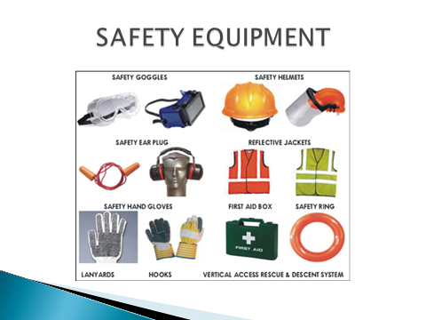

Types of hazards at workplace:
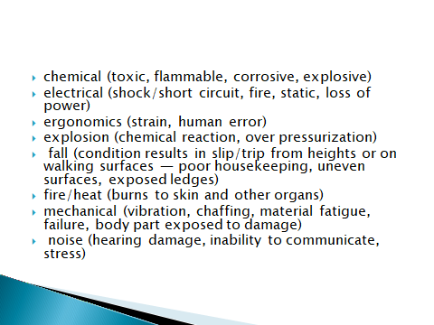
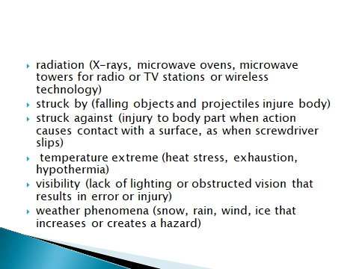

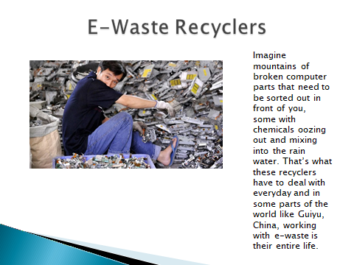

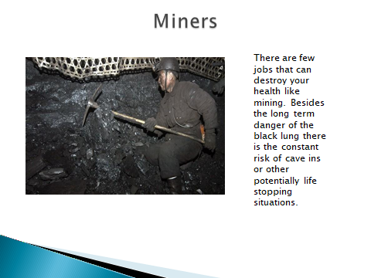

I ANSWER THE FOLLOWING QUESTIONS
1.What is risk assessment and how often should it be done?
2. Name some parts of the protective equipment and state how this equipment protects workers at their workplace.
3. Are hazard and risk one and the same concept?
4. Provide some examples of physical and psychosocial hazardous situations.
5. Translate the part of the text on worker responsibilities regarding safety at work.
6. What are the tasks of a risk manager?
7. Which of the jobs mentioned above involves the greatest risk at work in your opinion?
8. Describe one job (not mentioned earlier) which is dangerous in your opinion.

